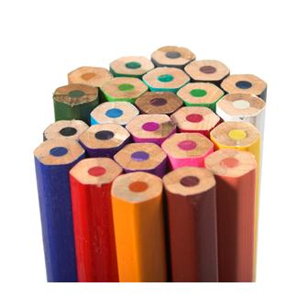

# THIRD GRADE

* Backpack
* 1" Binder
* 2 Pkgs Notebook Paper (wide-ruled, 3-hole punched)
* 24 Pencils, (Ticonderoga preferred, pre-sharpened)
* 24-Box Crayons (Crayola preferred)
* 1 Box Markers
* 3 Erasers (pink, wedge)
* 3 Glue Sticks
* 4 Dry Erase Markers
* 4 Composition Books (wide-ruled)
* 4 Pocket Folders (pockets on the bottom, no brads)
* 1 Pencil Box (no lock & key)
* 3 Pads Post-It Notes (3” x 3”)
* 2 Red Pens
* 3 Highlighters
* Ear Buds
* 1 Box Gallon-size Ziploc bags

### KINDERGARTEN

### (* = label with name)

* Backpack*
* 12 Pencils (Ticonderoga preferred,

pre-sharpened)

* 24-Box Crayons (Crayola preferred)
* 24-Box Colored Pencils
* 10-Box Markers (Crayola classic)
* 5 Erasers (pink, wedge)
* 5 Large Glue Sticks
* 4 Dry Erase Markers (any color)
* 1 Composition Notebook
* 1 Pencil Box* (the kind that snaps shut)
* 1 Box Sandwich-size Ziploc Bags

(Last name starts with A-N)

* 1 Box Gallon-size Ziploc Bags

(Last name starts with O-Z)

**HOLLYWOOD HILL ELEMENTARY**

**SCHOOL SUPPLY LIST**

**2019 - 2020**

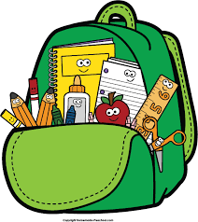

**FOURTH GRADE**

* Backpack
* 4 Pkgs Notebook Paper (wide-ruled)
* 24 Pencils (Ticonderoga preferred, pre-sharpened)
* 2 Red Pens
* 12-Box Colored Pencils
* 3 Highlighters
* 12-Box Markers
* 24 Erasers (pencil top)
* 2 Erasers (pink, wedge)
* 4 Dry Erase Markers (black, wide tip)
* 4 Composition Books (wide-ruled, not spiral)
* 4 Pocket Folders (no brads)
* 1 Pencil Pouch/Bag
* 6 Pads Post-It Notes (3” x 3”)
* 3 Glue Sticks
* 24-Box Crayons (Crayola preferred)
* Earbuds or Headphones (label with name)

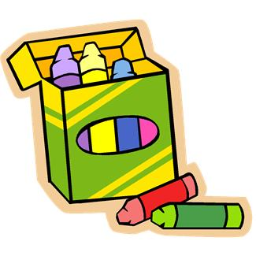

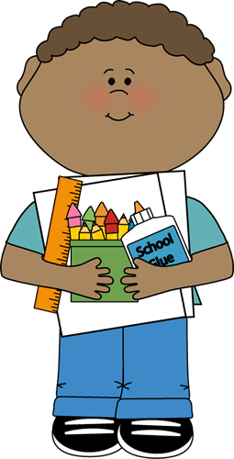

**FIFTH GRADE**

* Backpack
* 2” Binder (3-ring, not zippered)
* 2 Packages Dividers (with write-on tabs)
* 1 Pkg Notebook Paper (wide-ruled)
* 48 Pencils (Ticonderoga preferred, pre-sharpened)
* 24-Box Crayons (Crayola preferred)
* 1 Box Colored Pencils (Crayola preferred)
* 2 Red Pens
* 1 Box Broad-tip Markers (Crayola preferred)
* 2 Packages Erasers (pencil top)
* 2 Erasers (pink, wedge)
* 4 Composition Books (wide-ruled, no spirals)
* 1 Pencil Pouch (zippered, not a box)
* 4 Pads Post-It Notes (3” x 3”, yellow)
* 2 Dry Erase Markers
* 2 Highlighters
* 2 Glue Sticks
* Earbuds

# SECOND GRADE

* Backpack
* 12 Pencils (Ticonderoga preferred,

pre-sharpened)

* 24-Box Crayons (Crayola preferred)
* 10-Box Markers
* 1 Eraser (pink, wedge)
* 2 Spiral Notebooks (wide-ruled)
* 2 Pocket Folders
* 1 Pencil Box
* 2 Pads Post-It Notes (3” x 3”)
* 2 Composition Books (wide-ruled)

# FIRST GRADE

# (* = label with name)

* Backpack*
* 24 Pencils (Ticonderoga preferred,

pre-sharpened)

* (2) - 24-Box Crayons (Crayola preferred)
* 10-Box Broad Line Markers (Crayola preferred)
* 1 Box Colored Pencils
* 8 Glue Sticks
* 1 Eraser (pink, wedge)
* 10 Dry Erase Markers (black, odorless)
* 1 Pencil Box (clear plastic, 8” x 4.5”, non-locking)
* 1 Plastic Pocket Folder*

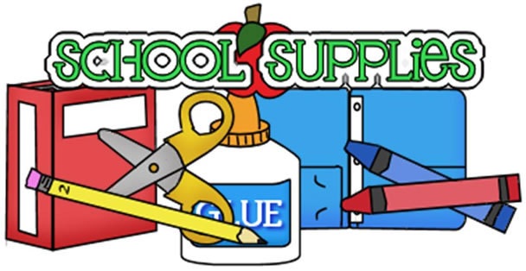

*If purchasing school supplies creates a financial hardship, please seek assistance from the Office Manager.*

*Supplies will be provided.*